MAJOR PROJECT STAGE-II REPORT ON
GRAPHICAL PASSWORD AUTHENTICATION
Submitted in partial fulfilment of the Academic requirements for the award of the
degree of

BACHELOR OF TECHNOLOGY
In
CSE-ARTIFICIAL INTELLIGENCE & MACHINE LEARNING

By
S. NANDHINI (23D45A6609)
M. AJAY (22D41A6683)
M. RITHWIK (22D41A6685)
N. AKHILA (22D41A6692)


Under the esteemed guidance of (Mrs. M. SWATHI REDDY)

DEPARTMENT OF
CSE- ARTIFICIAL INTELLIGENCE & MACHINE LEARNING

SRI INDU COLLEGE OF ENGINEERING & TECHNOLOGY

(An Autonomous Institute)
(Approved by AICTE, New Delhi & Permanently Affiliated to JNTU Hyderabad) Sheriguda(V), Ibrahimpatnam(M), R.R. Dist-501 510
2025-2026

SRI INDU COLLEGE OF ENGINEERING & TECHNOLOGY

(An Autonomous Institute)

(Approved by AICTE, New Delhi & Permanently Affiliated to JNTU Hyderabad)
DEPARTMENT OF
CSE-ARTIFICIAL INTELLIGENCE & MACHINE LEARNING



CERTIFICATE
This is to certify that the Major Project stage – I entitled “Graphical Password Authentication System” is submitted in partial fulfilment for the award of Degree of Bachelors of Technology in CSE- Artificial Intelligence and Machine Learning of Sri Indu College of Engineering &Technology, Hyderabad for the academic year 2025-2026. This is a record of the project work done by S.Nandhini (23D45A6609), M.Ajay (22D41A6683), M.Rithwik (22D41A6685), N.Akhila (22D41A6692), which has been approved as it satisfies academic requirements in respect of the work prescribed for IV YEAR, II-SEMESTER of B.TECH course.

Mrs. M. SWATHI REDDY Prof.G UMA MAHESHWARI
(Internal Guide) (Head of the Department)

EXTERNAL EXAMINER

DECLARATION

We hereby declare that the "GRAPHICAL PASSWORD AUTHENTICATION" was carried out by us towards the fullfilment of the curriculum required for the award of B. Tech IV Year II Semester at SRI INDU COLLEGE OF ENGINEERING AND TECHNOLOGY. This project is an original work done by us and not been submitted by any other university or institution for the award of any other degree and this work is not any other the same as that of any other and has not been submitted to anywhere else for the award of degree.

- .………………………….

- ……………………………

- ……………………………

- …………………………….

ACKNOWLEDGMENT

With great pleasure we want to take this opportunity to express our heartfelt gratitude to all the people who helped in making this project work a success. We thank the almighty for giving us the courage & perseverance in completing the project.
We are thankful to Principal Prof. Dr. G. SURESH, for giving us the permission to carry out this project and for providing necessary infrastructure and labs.
We are highly indebted to, Prof. G. UMA MAHESHWARI, Head of the Department of CSE-Artificial Intelligence and Machine Learning, for providing valuable guidance at every stage of this project
We are grateful to our internal project guide, M. SWATHI REDDY , Asst .Professor for his constant motivation and guidance given by his during the execution of this project work.
We would like to thank the Teaching & Non-Teaching staff of Department of CSE- Artificial Intelligence and Machine Learning for sharing their knowledge with us.
Last but not the least we express our sincere thanks to everyone who helped directly or indirectly for the completion of this project

S. NANDHINI (23D45A6609)
M. AJAY (22D41A6683)
M. RITHWIK (22D41A6685)
N. AKHILA (22D41A6692)

ABSTRACT

Graphical password authentication system designed to enhance the overall security and usability of conventional login systems. Traditional text-based passwords are widely used but remain vulnerable to common attacks such as password guessing, dictionary attacks, phishing, and shoulder surfing. To overcome these limitations, the proposed system integrates a visual authentication step based on iris images combined with hidden watermark messages, thus adding multiple layers of verification while retaining ease of use.
In the proposed system, the registration process begins with the user providing a username and password, along with uploading an iris image and entering a secret watermark message. The system embeds the watermark message securely inside the iris image, creating a visually unchanged but information-rich image. This watermarked iris image is then stored on the server along with the user’s login credentials. The combination of graphical input and hidden information provides an additional security layer beyond what typical text- based authentication can offer.
During the login process, the user enters their username, password, watermark message, and uploads the original iris image. The system first validates the textual credentials. If they are correct, it proceeds to compare the uploaded iris image with the one stored during registration to verify integrity and authenticity. The system then extracts the embedded watermark message from the stored iris image and compares it with the user-provided message. Only when all these checks—credentials, image match, and watermark verification—are satisfied does the system grant access. Any mismatch at any stage immediately results in authentication failure, thereby preventing unauthorized usage.
The system is implemented using Python Django as the web framework and MySQL as the database for storing user information and watermarked images. The application can be executed by importing the database content from the provided script, starting the Django server, and accessing the web interface through the given URL. The interface supports user registration, image upload, watermark embedding, secure login, and error handling for mismatches or invalid inputs. Overall, this project demonstrates an improved authentication mechanism that unites graphical input, hidden watermark data, and traditional credentials. This multi-factor approach delivers stronger protection against unauthorized access while maintaining a simple, intuitive, and user-friendly experience for end users.

i

CONTENTS
Sl. No. PageNo.
ABSTRACT i
LIST OF FIGURES iv
LIST OF TABLES iv
LIST OF SCREENSHOTS iv
- INTRODUCTION 1-5
  - Motivation 1-3
  - Objective…………………………………………………………………3-5
- LITERATURE SURVEY 6-9
- EXISTING SYSTEM 10-13
  - Challenges in Existing System……………………………………………13
- PROPOSED SYSTEM 14-18
- SYSTEM REQUIREMENTS 19-26
  - Software Requirements…………………………………………………….26
  - Hardware Requirements……………………………………………………26
- MODULES 27-28
- SYSTEM DESIGN 29-44
  - System Architecture Diagram 29-32
  - Use Case Diagram 33-35
  - Class Diagram 36-38
  - Sequence Diagram 39-41
  - Activity Diagram 42-44
- ALGORITHMS 45-48
- IMPLEMENTATION 49-53
  - Sample Code 49-52
  - Sample Test Cases 53
  - Sample Data Set 53

ii

- TESTING 54-56
- OUTPUT SCREENSHOTS 57-58
- CONCLUSION 59
- FUTURE SCOPE 60
- REFERNCES 61
- PUBLICATION DETAILS.........................................................………………..

iii

LIST OF FIGURES

Sl.No. Page No.
Fig.7.1.1: System Architecture 32
Fig.7.2.1 :Use Case Diagram 35
Fig.7.3.1:Class Diagram 38
Fig.7.4.1 :Sequence Diagram 41
Fig.7.5.1 :Activity Diagram 44

LIST OF SCREENSHOTS

Sl.No. Page No.
Fig. 9.3.1 Test images 63

Fig-10.1: Output Screenshots 57-58

LIST OF TABLES

Sl.No. Page No.

Table2.1: Literature Survey 7
Table 4.1 : Advantages of Proposed System 14
Table 5.1: Software Requirements 26
Table 5.2: Hardware Requirements 26

iv

INTRODUCTION

Motivation
In recent years, the rapid growth of digital services and online platforms has significantly increased the need for secure and reliable authentication mechanisms. As users continue to interact with a wide range of applications—banking portals, e-commerce sites, healthcare systems, and cloud services—the protection of personal data and sensitive information has become a critical concern. Despite this growing demand for stronger security, traditional text- based authentication remains the dominant method used in most systems. However, it also remains one of the weakest points in securing user accounts. This gap between increasing security needs and the limitations of conventional methods serves as the primary motivation for the development of a more robust and user-friendly authentication scheme.
Traditional passwords suffer from several well-known weaknesses. Users tend to choose simple, easy-to-guess passwords, reuse the same password across multiple platforms, or write them down due to difficulty remembering complex combinations. These practices make systems vulnerable to brute-force attacks, dictionary attacks, and social engineering techniques. Furthermore, passwords can be stolen through phishing, keylogging, shoulder surfing, or data breaches, leaving users exposed to unauthorized access. Even when systems enforce strict password policies, such as requiring special characters or frequent password changes, these rules often lead to user frustration rather than improved security. Thus, there is a pressing need for an authentication method that not only strengthens security but also reduces the cognitive burden on users.
Graphical authentication techniques have emerged as a promising alternative due to the well- established psychological observation that humans remember images better than text. Visual memory is stronger and more intuitive, making graphical passwords easier for users to recall while still offering greater complexity. However, many existing graphical password systems face drawbacks such as susceptibility to shoulder-surfing or the need for large image databases. Additionally, these systems may rely heavily on user interactions that can be observed or replicated by attackers. This motivates the need for a solution that combines the memorability of graphical input with layers of protection against common attack techniques.
Another major motivating factor for this project is the increasing integration of multimedia data in security applications. Image-based authentication offers unique opportunities to embed

additional information—such as secret codes or identifiers—within images without affecting their visual appearance. Digital watermarking, in particular, has emerged as a powerful tool for embedding hidden information inside images in a secure and tamper-resistant manner. Watermarking provides an extra layer of verification beyond the visible image, thereby making attacks significantly more difficult. By combining graphical images with embedded watermark messages, it becomes possible to design an authentication scheme that is both user-friendly and resistant to manipulation.
The proposed system takes advantage of this concept by embedding a user-defined watermark message inside a chosen iris image during registration. This process provides a dual function: the image itself acts as a graphical password, while the embedded watermark serves as a hidden authentication token. Even if an attacker attempts to replicate or steal the image, the absence of the correct watermark message ensures that authentication will fail. This increases security without placing additional burden on the user. The user simply needs to remember the same message they used during registration and upload the correct image during login. The hidden nature of the watermark adds a layer of secrecy, making it very difficult for outsiders to identify or modify.
Usability is another key motivating element behind this project. Many secure authentication systems become impractical if they require complex or time-consuming user actions. For example, multi-factor authentication through physical devices or SMS codes can be inconvenient and may fail if the user does not have access to their device. The motivation behind this graphical password authentication system is to provide a multi-layered approach without complicating the user experience. By integrating graphical input, watermark verification, and simple login credentials, the system seamlessly blends strong security measures with ease of use. Users simply interact with a familiar and intuitive interface involving image uploads and basic information, eliminating the need for specialized devices or lengthy processes.
There is also a growing need for flexible authentication systems that can be deployed across educational institutions, research environments, corporate applications, and personal platforms. A scheme that combines graphical passwords with hidden watermark details can be adapted to a wide range of use cases, making it an attractive solution for both small-scale and large-scale implementations. Its reliance on standard technologies such as Python Django and MySQL ensures accessibility for developers and easy integration into existing systems.

Finally, the increasing concern over privacy breaches and unauthorized data access creates a strong motivation to design authentication mechanisms that focus on both security and reliability. As attackers become more sophisticated, single-layer authentication methods are no longer sufficient. The proposed system offers a layered approach that strengthens protection without sacrificing simplicity. By motivating users to adopt more secure login practices without overwhelming them, the system contributes to the broader goal of promoting cybersecurity awareness and safety.
In summary, this project is motivated by the limitations of traditional text-based passwords, the advantages of graphical memory, the potential of digital watermarking for secure data embedding, and the need for user-friendly yet highly secure authentication methods. The combination of these factors drives the development of a novel authentication scheme that addresses modern cybersecurity challenges while delivering a practical and intuitive user experience.

Project Objectives:

The primary objective of this project is to design and develop a novel graphical password authentication system that enhances the security and usability of traditional login methods. As modern applications increasingly require reliable protection against unauthorized access, it has become essential to move beyond conventional text-based password schemes. This project aims to introduce a multi-layered authentication model that utilizes both graphical input and hidden watermark verification to create a stronger, more user-friendly security framework.
One of the core objectives of the project is to overcome the vulnerabilities of traditional password systems. Despite being widely used, text-based passwords are susceptible to numerous attacks such as brute force, phishing, keylogging, and shoulder surfing. Most users also tend to reuse passwords or choose simple combinations that are easy to remember, which reduces overall security. By introducing a graphical password component—specifically an iris image—the project seeks to shift authentication toward a more visual and memorable approach, reducing the dependency on weak text inputs. This objective supports the broader goal of improving cybersecurity practices among users.
A key objective is to integrate digital watermarking into the authentication process to add an invisible layer of security. During registration, the system embeds a secret watermark message into the uploaded iris image. This hidden message acts as an additional authentication token that cannot

be easily observed or altered by potential attackers. The objective here is to ensure that even if someone obtains a copy of the graphical password, they will still fail authentication without the correct embedded watermark. This enhances the robustness of the system by linking the graphical password to a concealed verification mechanism.
Another objective is to develop a reliable mechanism for image verification during login. The system must be able to compare the iris image uploaded at login with the watermarked version stored on the server. This objective focuses on ensuring that the image submitted during login matches the one used at registration, thereby preventing attacks where users attempt to authenticate with manipulated or unrelated images. Achieving accurate image comparison reinforces the integrity of the authentication process.
Additionally, the project aims to implement a secure and user-friendly login workflow. Security systems frequently fail due to complexity, making users unwilling to adopt them. Therefore, a major objective is to design the entire process—registration, watermark embedding, and login—in a way that remains intuitive even for non-technical users. The interface should be simple to navigate, requiring minimal user effort while still ensuring strong protection. This objective emphasizes balancing security with usability, ensuring that enhanced security does not come at the cost of convenience.
Another important objective is to support a multi-factor authentication structure without relying on external hardware devices or OTP systems. Instead of physical tokens or mobile-based verification, the project incorporates multiple layers—credentials, graphical image comparison, and watermark matching—within a single integrated workflow. This keeps authentication secure yet efficient, making it suitable for academic, corporate, and web-based platforms where users may not have access to external devices. Achieving this objective contributes to increasing accessibility while maintaining high security standards.
From a technical perspective, an objective of the project is to implement the system using reliable and widely supported technologies. The application is built using Python Django for backend development and MySQL for secure data storage. These technologies were chosen for their scalability, stability, and community support. The objective is to ensure that the system can be deployed easily, maintained efficiently, and potentially expanded in the future. This technical goal supports the long-term applicability and relevance of the system.
Another objective is to ensure secure storage and processing of user data. The system must store usernames, passwords, and watermarked images in a secure manner to prevent unauthorized

access. Passwords must not be stored in plain text, and images must be managed in a controlled environment to prevent tampering. Meeting this objective ensures that the system provides end-to- end protection beyond just the authentication process.
The project also aims to evaluate the performance and effectiveness of the proposed authentication scheme. This includes assessing how well the system resists unauthorized login attempts, how accurately it verifies image and watermark matches, and how easily users can navigate the interface. By testing the system across different scenarios, the objective is to validate its effectiveness and demonstrate improvements over traditional authentication methods.
Finally, a broader objective of the project is to contribute to ongoing research in secure authentication systems by providing a practical, innovative solution that combines graphical passwords with digital watermarking. This project seeks to highlight the potential of hybrid authentication mechanisms and inspire further exploration into user-centric security models. Achieving this objective allows the project to not only solve a practical problem but also add value to the field of cybersecurity research.
In summary, the objectives of this project include improving security, enhancing usability, integrating hidden watermark verification, ensuring reliable image comparison, establishing a user- friendly workflow, supporting secure multi-factor authentication, utilizing robust technologies, protecting stored data, evaluating system performance, and contributing to advancements in authentication methods. Together, these objectives guide the development of a comprehensive and innovative authentication system that meets modern security needs while remaining accessible to everyday users.

LITERATURE SURVEY

The Graphical password authentication has been widely explored as an alternative to traditional text-based systems due to its potential to enhance security and usability. Williams (Literature Survey 1) provides a foundational overview of graphical password methods, discussing diverse techniques and highlighting their advantages and drawbacks, which establishes an essential understanding of this authentication paradigm. Building on this, Davis (Survey 2) examines the cognitive aspects influencing user behaviour and memorability, emphasizing how psychological factors play a crucial role in the effectiveness of graphical passwords. Martinez (Survey 3) contributes a security-focused perspective, identifying vulnerabilities and emerging threats associated with graphical authentication, thus underscoring the need for stronger protection mechanisms. Thompson (Survey 4) shifts the focus to usability and user experience, exploring user preferences, challenges, and design considerations that impact adoption and practicality. Lastly, Turner (Survey 5) explores innovative multimodal approaches by integrating biometrics and gesture-based methods with graphical passwords, demonstrating how combining multiple factors can significantly improve both security and user convenience. Together, these studies provide a comprehensive foundation for understanding the evolution, challenges, and future trajectories of graphical password authentication systems.

IEEE-Style Related Work Section Related Work
Graphical password authentication has been extensively studied as a secure and user- friendly alternative to traditional text-based systems. Williams [1] presents a comprehensive review of graphical password techniques, outlining their mechanisms, strengths, and limitations, thereby establishing a broad understanding of existing authentication approaches. Davis [2] investigates the cognitive aspects involved in graphical password usage, focusing on user memorability, behavioral patterns, and psychological factors that influence authentication performance. Martinez [3] offers a detailed security analysis of graphical password schemes, identifying current vulnerabilities, attack models, and potential improvements needed to strengthen graphical authentication

Ref.  No. | Author(s) | Year | Title | Contribution / Key Insights
1 | Sarah E. Williams | 2018 | Graphical Passwords: A Comprehensive Review of User Authentication Methods | Foundational review of graphical password schemes, their design categories, strengths, and  limitations.
2 | Michael J. Davis | 2019 | Cognitive Aspects of Graphical Passwords | Explores psychological and  memory-based factors affecting graphical password performance.
3 | Emily R. Martinez | 2020 | Security Analysis of Graphical Passwords | Provides analysis of attacks such  as shoulder surfing, hotspots, and brute force vulnerabilities.
4 | David A. Thompson | 2021 | Usability and User Experience in Graphical Passwords | Evaluates usability challenges including cognitive load, interaction complexity, and user  satisfaction.
[5] | Jessica L. Turner | 2022 | Multimodal Graphical Password Authentication | Integrates biometrics and gesture  inputs to enhance graphical password strength.
[6] | S. Joyce & S. Veni | 2023 | Iris Biometric Watermarking Using DWT-SVD | Proposes a robust watermarking technique for secure iris-based  authentication.
[7] | Mayank Vatsa et al. | 2015 | Secure Multimodal Biometric  System Using Digital Watermarking | Enhances biometric template  security using watermarking and multimodal fusion.
[8] | Priyanka Singh et al. | 2021 | Adaptive Blind Watermarking for Image Authentication | Improves watermark robustness against compression, noise, and  geometric attacks.
[9] | Christy et al. | 2016 | Survey on Digital Watermarking for  Authentication | Reviews image authentication watermarking methods and their  security implications.
[10] | Anushikha Singh et al. | 2013 | Secure Digital Image  Watermarking Using Iris Features | Uses iris features to improve  watermark-based authentication security.

Drawbacks:

Sarah E. Williams (2018) – Graphical Passwords: A Comprehensive Review of User Authentication Methods
It does not provide practical implementation or experimental validation of the discussed methods. The research also lacks discussion on integrating graphical password systems with modern authentication frameworks used in real-world applications.

Michael J. Davis (2019) – Cognitive Aspects of Graphical Passwords
The study concentrates on psychological and cognitive factors such as memory retention and user perception in graphical passwords. While it provides insights into human memory behavior, it does not deeply analyze the technical security aspects of graphical password systems or their resistance to modern cyberattacks.

Emily R. Martinez (2020) – Security Analysis of Graphical Passwords
This research analyzes security vulnerabilities such as shoulder surfing, hotspot attacks, and brute-force attacks in graphical password systems. However, it mainly focuses on identifying weaknesses rather than proposing effective solutions or advanced countermeasures to overcome these vulnerabilities.

David A. Thompson (2021) – Usability and User Experience in Graphical Passwords
The study evaluates the usability and interaction complexity involved in graphical password systems. Although it highlights the challenges faced by users, the research gives limited attention to the security improvements required to protect such systems from evolving cyber threats.

Jessica L. Turner (2022) – Multimodal Graphical Password Authentication
This work introduces a multimodal authentication approach by combining graphical passwords with biometrics and gesture inputs. While it enhances security, the approach requires additional hardware and higher computational resources, making it difficult to implement in low-cost or resource-limited environments.

S. Joyce & S. Veni (2023) – Iris Biometric Watermarking Using DWT-SVD
The proposed watermarking technique improves authentication security using iris biometric data. However, the method depends heavily on the quality of iris images, and its performance may decrease when images are affected by noise, distortion, or low resolution.

Mayank Vatsa et al. (2015) – Secure Multimodal Biometric System Using Digital Watermarking
This research enhances biometric security by combining multiple biometric traits with digital watermarking techniques. However, multimodal biometric systems often require high storage capacity and computational power, which can increase system complexity and processing time.

Priyanka Singh et al. (2021) – Adaptive Blind Watermarking for Image Authentication
The proposed watermarking technique improves robustness against image compression and noise attacks. Despite its advantages, the method may affect the visual quality of images and may not perform effectively under severe geometric distortions.

Christy et al. (2016) – Survey on Digital Watermarking for Authentication
This study provides a comprehensive overview of various digital watermarking techniques used for authentication. However, since it is a survey-based study, it does not include experimental implementation or performance evaluation of the methods discussed.

Anushikha Singh et al. (2013) – Secure Digital Image Watermarking Using Iris Features
This work integrates iris biometric features into digital watermarking to strengthen authentication security. However, the method relies on accurate iris feature extraction, and its effectiveness may decrease when the iris images are blurred, noisy, or captured under poor lighting conditions.

EXISTING SYSTEM
Traditional user authentication systems primarily rely on text-based passwords, where users create a combination of letters, numbers, and symbols to secure access to digital platforms. This approach is widely used due to its simplicity, low implementation cost, and long-standing acceptance across computer systems. In addition to text-based authentication, some systems incorporate PIN- based access, security questions, or one-time passwords (OTP) to enhance security. However, these mechanisms still fundamentally depend on knowledge-based authentication—something the user knows
Another evolving category of authentication systems involves single-modality biometrics, such as fingerprint or facial recognition. While biometrics provide greater security due to their uniqueness, they are often used in isolation, without additional layers of validation to counter spoofing attacks or image-based replication. Moreover, most existing graphical authentication systems are limited to click-based passwords, pattern drawing, or recognition-based schemes such as selecting images or icons from a grid. Although graphical passwords improve memorability and reduce reliance on textual complexity, they still inherit several shortcomings, including predictability, shoulder surfing susceptibility, and limited entropy.
Overall, existing systems generally fall into three categories:

- Text-based password systems

- Single-factor graphical password systems

- Biometric-only authentication systems

While each category offers certain advantages, none provide a truly robust defense against modern, sophisticated security threats.

Limitations of Text-Based Password Systems

Text-based authentication remains the most commonly used method because it is simple and easy to deploy. However, it suffers from serious vulnerabilities:

Weak Password Creation

Users tend to choose easy-to-remember passwords, such as names, common words, or predictable sequences. These passwords are extremely vulnerable to:
    - Dictionary attacks

    - Brute-force attacks

    - Guessing attacks

Password Reuse

Many users reuse the same password across multiple platforms. If one system is compromised, the attacker gains access to several other accounts.

Memorability Issues

Strong passwords that meet security standards (uppercase, lowercase, symbols, length) are harder to remember. This leads users to:
    - Write passwords on paper

    - Store them insecurely

    - Reset passwords frequently

Susceptibility to Social Engineering

Text-based systems are highly vulnerable to:

    - Phishing

    - Shoulder surfing

    - Keylogging

These attack vectors remain difficult to prevent with password-only systems.

Lack of Multi-Layer Security

Most existing systems rely solely on password verification, lacking additional layers that could verify identity more reliably.

Limitations of Graphical Password Systems

Graphical authentication was introduced to address the memorability problems of text-based passwords, but existing implementations face their own challenges.

Predictable Patterns

Many users select predictable click-points or draw simple patterns, reducing password space and making it easier for attackers to guess or reproduce.

Shoulder Surfing Risk

If an attacker observes the user selecting images or drawing a pattern, the password can be easily replicated. This is especially problematic in public or shared environments.

Limited Image Choice

Most systems use fixed sets of images, icons, or grids. Attackers familiar with the system may narrow down possible inputs or use statistical guessing to determine likely password combinations.

Replay Attacks

Static graphical inputs can be captured and reused by attackers without the system recognizing the difference.

Image-Based Attacks

High-resolution screenshots or recordings can be used to mimic user authentication even without detailed system knowledge.
Although graphical passwords improve usability, they do not solve core problems related to strengthening security or preventing unauthorized access.

Limitations of Biometric-Only Systems

Biometric authentication—such as iris, fingerprint, or face recognition—has become more popular. However, relying solely on biometrics has significant concerns:

Spoofing and Presentation Attacks

High-quality images or 3D masks can sometimes fool facial or iris recognition systems. Fake fingerprints or silicone molds can also deceive sensors.

Irreversibility

Unlike passwords, biometrics cannot be reset. If compromised, the user cannot change their fingerprint or iris pattern.

Environmental Sensitivity

Lighting, camera quality, sensor damage, and user conditions (injuries, changes in appearance) can cause false rejections or poor accuracy.

Privacy and Storage Concerns

Biometric data requires extremely secure storage, as leakage of such data has long-term consequences.

Single Layer of Verification

Most biometric systems rely solely on the biometric match, lacking multi-factor verification.

Overall Challenges in Existing Authentication Systems

- Lack of Multi-Factor Security

Most existing systems rely on only one authentication factor:

    - A password

    - A biometric

    - A pattern or click-point

This single point of verification increases the chance of system compromise.

Increasing Sophistication of Cyber Attacks

Modern attackers use:

    - AI-generated spoof images

    - Automated brute-force tools

    - Phishing kits

    - Deepfake technologies

Traditional systems are not built to counter these advanced methods.

Usability vs. Security Trade-off

Highly secure systems are often difficult for users, while user-friendly systems tend to compromise on security. Achieving a balance remains a significant challenge.
watermarks) that can verify authenticity of the input

4.PROPOSED SYSTEM

Introduction to the Proposed System

The proposed system introduces a multi-layered authentication mechanism that integrates traditional text-based credentials, biometric iris recognition, and digital watermarking to create a highly robust and tamper-resistant authentication process. In contrast to existing systems that rely on a single authentication factor, this model combines three independent verification layers—something the user knows (password), something the user is (iris biometric), and something the user owns/creates (watermarked image). This approach significantly reduces the probability of unauthorized access, image spoofing, and password breaches. The system ensures greater reliability, enhanced user convenience, and high resistance to various cyber threats including phishing, brute force attacks, image forgery, and replay attacks.

System Overview

The proposed model operates on the principle of integrating biometric-based graphical authentication with embedded watermark verification. During registration, the user submits a username, password, an iris image, and a secret watermark message. This watermark message is embedded into the iris image using digital watermarking techniques, ensuring the authenticity and integrity of the biometric data. During login, the user must re-enter the credentials and upload the iris image containing the watermark. The system extracts and verifies the watermark, compares the biometric features of the iris, and validates the text-based credentials. Authentication is granted only when all three factors match successfully.

This multi-factor, multi-channel verification creates a highly secure authentication workflow resistant to identity theft, credential leakage, and image manipulation.

System Architecture

The system architecture consists of the following key modules:

User Interface Module

Provides the interactive interface through which users can:

    - Register by submitting credentials, iris image, and watermark message
    - Login by uploading the iris image and entering credentials
    - Receive authentication results

Digital Watermarking Module

This module embeds the watermark message into the user’s iris image securely.

    - Embedding Process: Uses algorithms such as Least Significant Bit (LSB), Discrete Wavelet Transform (DWT), or Discrete Cosine Transform (DCT) to hide textual information within the iris image without perceptible alterations.
    - Extraction Process: Recovers the hidden watermark from the uploaded user image during authentication.

The watermark ensures the system can detect image forgery, duplication, or tampering attempts.

Iris Feature Extraction and Matching Module

Uses biometric algorithms to analyze and verify the uniqueness of the iris pattern.

    - Performs segmentation, normalization, feature extraction
    - Compares extracted features using Hamming distance or Gabor filters
    - Ensures the uploaded iris truly belongs to the registered user

Credential Verification Module

Validates username and password by comparing them with securely stored hash values. Utilizes modern hashing algorithms such as SHA-256, PBKDF2, bcrypt, or Argon2.

Database Module

Stores:

    - Username
    - Hashed password
    - Watermarked iris image
    - Extracted biometric templates

Sensitive data is stored in encrypted form to maintain confidentiality.

Authentication Decision Engine

Combines results from:

    - Password verification
    - Iris biometric matching
    - Watermark extraction and comparison

Authentication is successful only if every parameter matches, ensuring multi-layer protection.

Registration Process (Proposed System)

During registration, the system performs the following steps:

User Input Collection
  - Username
  - Password
  - Iris image
  - Secret watermark message

Password Hashing
The password is converted into a secure hash and stored.

Iris Image Processing
  - Image normalization and noise removal
  - Feature extraction (for future matching)

Digital Watermark Embedding
  - The watermark message is encrypted
  - Embedded using DWT/DCT or LSB techniques
  - Watermarked image is stored in the database

Final Storage
The server securely stores:
  - Username
  - Hashed password
  - Watermarked iris image
  - Biometric features

This results in a unique encrypted–biometric credential set.

Login Process (Proposed System)

During authentication, the system performs the following:

User Credential Submission
User logs in with username, password, and a new iris image containing the same watermark.

Password Verification
Entered password is hashed and compared with stored value.

Watermark Extraction
  - Extracts hidden watermark from uploaded iris image
  - Compares it with the originally embedded message

Iris Biometric Matching
  - Extracts features from the uploaded image
  - Performs pattern matching with stored iris template
  - Confirms if biometric data matches the registered user

Final Authentication
Access is granted only if:
  - Password matches
  - Iris features match
  - Watermark message matches

If any one factor fails, authentication is denied. This multi-layer validation ensures extremely high security against unauthorized access.

Advantages of the Proposed System

  - Strong Multi-Factor Authentication

Combines password + biometric + watermark, making it difficult to bypass.

High Resistance to Attacks

Protects against:

    - Spoofing
    - Shoulder surfing

    - Brute-force
    - Replay attacks
    - Biometric forgery
    - Image manipulation

Tamper Detection

Watermark ensures image integrity and prevents the use of forged/edited biometric data.

Enhanced Usability

Users do not need long, complex passwords; the iris and watermark provide strong additional layers.

Secure Data Storage

Biometric templates and watermarked images are stored securely with encryption.

Improved Accuracy

Combining biometric and graphical checks improves reliability and reduces false acceptance/rejection rates.

5. SYSTEM REQUIREMENTS
The system requirements define the essential capabilities, constraints, and performance expectations of the proposed Graphical Password Authentication System integrating text-based credentials, iris biometrics, and digital watermarking. These requirements guide the design, development, implementation, and evaluation of the system to ensure that it meets both functional objectives and quality standards.

Functional Requirements

Functional requirements describe what the system must do to achieve its intended purpose.
They outline the behavior, operations, and interactions that the system must support.

User Registration

FR1: User Credential Input

The system shall allow users to create an account by providing:

- A unique username
- A secure password

FR2: Iris Image Upload

The system shall enable users to upload a valid iris image during registration. The uploaded image must be in acceptable formats (e.g., JPG, PNG, BMP).

FR3: Watermark Message Input

The system shall allow users to input a secret watermark message (text string) that will be embedded into their iris image.

FR4: Watermark Embedding

The system shall embed the watermark message into the user’s iris image using a digital
watermarking algorithm such as LSB, DWT, or DCT.

FR5: Password Hashing

The system shall hash the user's password using secure hashing algorithms (e.g., SHA-256, bcrypt, Argon2) before storage.

FR6: Data Storage

The system shall store:

- Username
- Hashed password
- Watermarked iris image
- Extracted iris biometric template

The storage must be secure and encrypted.

User Login/Authentication FR7: User Credential Verification
The system shall prompt users to enter their username and password for authentication.

FR8: Iris Image Upload for Login

The system shall require users to upload an iris image during login for biometric verification.

FR9: Watermark Extraction

The system shall extract the watermark from the uploaded iris image and compare it with the stored watermark.

FR10: Iris Biometric Matching

The system shall:

- Extract iris features from the uploaded image
- Match these features against the stored template using algorithms such as Gabor filters or Hamming distance

FR11: Multi-Factor Decision Engine

The system shall grant access only when:

- Username matches
- Password matches
- Watermark message matches
- Iris biometric features match

If any parameter fails, authentication must be rejected.

- Error Handling & Feedback FR12: Invalid Input Handling The system shall:
- Validate uploaded images
- Display error messages for corrupted/incorrect formats
- Reject weak passwords

FR13: Authentication Feedback

The system shall provide meaningful feedback such as:

- “Login Successful”
- “Authentication Failed”
- “Incorrect Password”
- “Invalid Iris Image”

FR14: Account Recovery

The system shall provide a mechanism for account recovery using secure OTP/email verification.

Administrative Functions FR15: Admin Login
The system shall provide an admin interface for monitoring registered users and authentication logs.

FR16: User Management

Admins shall be able to:

- View user logs
- Remove suspicious accounts
- Manage system-level settings

Non-Functional Requirements

Non-functional requirements describe the quality attributes of the system, defining how the system must operate rather than specific behaviors. These ensure the system is efficient, maintainable, secure, and user-friendly.

Performance Requirements NFR1: Response Time
The system shall authenticate a user within 3–6 seconds, including biometric matching and watermark extraction.

NFR2: Scalability

The system shall support:

- At least 10,000 concurrent users
- Efficient database queries for large datasets

NFR3: Efficient Image Processing

Iris feature extraction and watermark operations shall execute without noticeable lag.

Security Requirements NFR4: Data Encryption
All sensitive data (passwords, images, templates) must be:

- Encrypted during transmission (HTTPS/TLS 1.2+)
- Encrypted at rest using AES-256 or equivalent

NFR5: Secure Authentication

The system must provide:

- Multi-factor authentication
- Protection against brute-force attacks
- Automatic lockout after multiple failed attempts

NFR6: Integrity Protection

The watermark ensures uploaded images are authentic and tamper-free.

NFR7: Biometric Template Protection

Biometric data must be stored in encrypted template format, not as raw images.

Usability Requirements NFR8: User-Friendly Interface
The interface shall be intuitive and easy to use for non-technical users.

NFR9: Accessibility

The system interface must be accessible across:

  - Laptops
  - Desktops
  - Mobile devices

NFR10: Clear Instructions

Users shall be guided through:

  - Image uploading
  - Password creation
  - Error recovery

Reliability Requirements NFR11: System Availability
The system shall maintain 99% uptime, ensuring reliable access.

NFR12: Backup and Recovery

The system shall:

- Perform daily backups
- Recover user data in case of server failure

NFR13: Fault Tolerance

The system must handle:

- Network delays
- Partial data losses Without crashing.

Maintainability Requirements NFR14: Modular Architecture
The system shall have modular components for:

  - Watermarking
  - Iris feature extraction
  - Authentication

- Database management

This ensures easy updates and maintenance.

NFR15: Error Logging

The system shall maintain logs for:

- Failed logins
- Admin actions
- System errors

Portability Requirements

NFR16: Cross-Platform Compatibility

The system shall run on:

- Windows
- Linux
- MacOS

NFR17: Browser Compatibility

Interface must support:

- Chrome
- Firefox
- Edge
- Safari

Privacy Requirements

NFR18: Biometric Data Confidentiality

Biometric data shall never be shared or accessible by unauthorized users.

Software Description

The proposed Graphical Password Authentication System is developed as a secure, multi- layered authentication application that integrates traditional credentials, iris biometrics, and digital watermarking. It is designed to enhance system security while maintaining user convenience.

The software provides two primary functionalities:

- User Registration: Allows users to create an account by submitting a username, password, iris image, and a secret watermark message. The password is securely hashed, and the watermark is embedded into the iris image using digital watermarking techniques. All data is stored securely in the backend database.
- User Authentication/Login: Enables users to log in by entering their credentials and uploading the iris image containing the embedded watermark. The system verifies the password, extracts and validates the watermark, and performs iris biometric matching. Access is granted only if all three factors match.

The software is built using modular architecture, separating the user interface, authentication engine, watermarking module, and biometric processing module. It ensures:

  - High security via encryption and multi-factor verification
  - Usability with a user-friendly interface
  - Cross-platform compatibility via a web-based interface or desktop application

Technologies used may include:

HARDWARE REQUIREMENTS:

    - System : i3 or above.

    - Hard Disk : 40 GB.

    - Ram : 4GB.

SOFTWARE REQUIREMENTS:

    - Operating system : Windows8 or Above.

    - Coding Language : python

6.MODULES

The Graphical Password Authentication System is divided into several functional modules to ensure efficient implementation, security, and maintainability. Each module performs a specific task within the system and contributes to the overall authentication process. The main modules of the system are described below.
1. User Registration Module
The User Registration Module is responsible for enrolling new users into the system. During the registration process, the user is required to provide essential credentials such as a unique username, password, iris image, and a secret watermark message. The system validates the input data and ensures that the username is unique. The password entered by the user is converted into a secure hash before being stored in the database to maintain confidentiality. The iris image uploaded by the user is then passed to the watermarking module where the secret message is embedded. After successful processing, all the necessary information including the username, hashed password, and watermarked iris image is securely stored in the database. This module acts as the initial step in building the user authentication profile.
2. Iris Image Processing Module
The Iris Image Processing Module handles the preprocessing and feature extraction of the iris image. Since the iris contains unique patterns that can be used for biometric identification, this module analyzes the iris image to identify distinct features. The process involves image normalization, noise removal, segmentation, and feature extraction. These extracted features form a biometric template that represents the unique identity of the user. The generated template is stored in the database and later used for comparison during the authentication phase. This module ensures that the biometric data is processed accurately for reliable user identification.
3. Digital Watermarking Module
The Digital Watermarking Module plays a crucial role in enhancing the security of the system. In this module, the secret watermark message provided by the user during registration is embedded into the iris image using digital watermarking techniques such as Least Significant Bit (LSB), Discrete Wavelet Transform (DWT), or Discrete Cosin e Transform (DCT). The watermark is embedded in such a way that it remains invisible to the human eye but can be extracted by the system when required. This technique ensures that the biometric image remains authentic and protects it from tampering or unauthorized use. The watermarked iris image is then stored in the database as part of the user's authentication data.
4. Database Management Module
The Database Management Module is responsible for securely storing and managing all system data. This includes user credentials, hashed passwords, watermarked iris images, and extracted biometric templates. The module ensures efficient storage, retrieval, and updating of records whenever necessary. Security mechanisms such as encryption and access control are implemented to protect sensitive information from unauthorized access. During the login process, this module provides the required data for verification and comparison. Proper database management ensures the integrity and reliability of the authentication system.
5. Login Authentication Module
The Login Authentication Module handles the user login process. When a registered user attempts to access the system, this module prompts the user to enter their username, password, and upload the iris image containing the watermark. The system first verifies the username and password by comparing them with the stored credentials in the database. If the credentials are valid, the uploaded iris image is forwarded to the watermark extraction and iris matching modules for further verification. This module serves as the gateway to the system and ensures that only registered users proceed to the next authentication stages.
6. Watermark Extraction Module
The Watermark Extraction Module is responsible for retrieving the hidden watermark message from the uploaded iris image during login. The system uses the same watermarking algorithm that was used during the embedding process to extract the hidden data. Once the watermark message is extracted, it is compared with the original watermark stored in the database. If the extracted watermark matches the stored one, the system confirms that the image is authentic and has not been altered. This module provides an additional security layer by ensuring the integrity of the biometric image.
7. Iris Matching Module
The Iris Matching Module verifies the biometric identity of the user. In this module, the system extracts features from the iris image uploaded during login and compares them with the biometric template stored in the database during registration. Advanced pattern matching techniques are used to calculate the similarity between the two sets of features. If the similarity score exceeds a predefined threshold, the iris is considered a match. This module ensures that the person attempting to log in is the same individual who registered in the system.
8. Authentication Decision Module
The Authentication Decision Module performs the final verification of the user. It integrates the results obtained from the password verification, watermark extraction, and iris matching modules. The system grants access only if all the authentication factors match successfully. If any of the verification steps fail, the login attempt is rejected and the user is denied access. This module ensures a secure multi-factor authentication mechanism by combining knowledge-based, biometric, and graphical verification techniques.

7.SYSTEM DESIGN

7.1 System Architecture Diagram:
The diagram represents the system architecture of a secure authentication system using Iris Biometric Matching and Steganography-based Watermark Verification. The system is divided into three major layers: Input Layer, Backend Layer, and Output Layer.

1. Input Layer
The Input Layer is the first stage of the system where the user interacts with the application. It acts as the interface between the user and the authentication system.
User Interface (Web Browser)
The system begins with a web-based user interface that allows the user to access the authentication system through a browser. The interface is designed to collect user credentials and biometric data required for verification.
Upload Image
The user uploads an iris image through the web interface. This iris image acts as the biometric authentication factor. Biometric authentication is considered more secure because iris patterns are unique for every individual.
User Input (Credentials & Files)
Along with the iris image, the user provides:
- Username
- Password
- Uploaded iris image file
These inputs are collected and sent to the server for processing.
MySQL Database
The credentials and related information are stored in a MySQL database. The database maintains:
- Registered user details
- Stored iris templates
- Encrypted watermark information
The database acts as a storage system that supports verification during the login process.
Login Attempt
Once the user submits the credentials and iris image, a login request is generated and sent to the backend layer for authentication.

2. Backend Layer
The Backend Layer is responsible for processing the user request, performing biometric verification, and validating the hidden watermark information.
Django Server
The system backend is implemented using a Django server, which handles all the application logic. Django processes the incoming request, retrieves stored data from the database, and performs the authentication algorithms.
Processing Stage
After receiving the login attempt, the Django server initiates the authentication workflow. This includes:
- Loading the stored iris template
- Preparing the uploaded image for feature extraction
- Performing comparison operations
Iris Biometric Match (Daugman Algorithm)
The second stage in the backend uses the Daugman Algorithm for iris recognition.
This process involves several steps:
- Iris Localization
The system detects the iris region from the uploaded eye image.
- Normalization
The iris region is converted into a standardized format to remove variations caused by pupil dilation or lighting.
- Feature Extraction
Unique iris features are extracted and converted into an iris code.
- Matching
The generated iris code is compared with the stored iris template in the database.
If the iris match score meets the required threshold, the authentication process continues. Otherwise, the login request is rejected.
Login Request Fail
If the iris biometric comparison fails, the system immediately rejects the login request. This prevents unauthorized access to the system.
Watermark Extraction and Comparison (Steganography Engine)
If the iris match is successful, the system proceeds to the next verification stage.
This stage involves steganography-based watermark verification, which enhances security.

The process includes:
- Watermark Extraction
The hidden watermark embedded inside the iris image is extracted.
- Data Comparison
The extracted watermark is compared with the watermark stored in the database.
- Integrity Verification
This step ensures that the image has not been tampered with or manipulated.
If the watermark matches successfully, the system confirms that the biometric image is authentic.

3. Output Layer
The Output Layer provides the final authentication results to the user.
Results Comparator
The results from the iris matching and watermark verification stages are sent to the Results Comparator.
This component determines whether authentication is successful or not by analyzing:
- Iris matching score
- Watermark verification result
Visualizer
If authentication is successful, the Visualizer component prepares the system output. It may display:
- Authentication success message
- User access confirmation
- System dashboard
Login Failed
If either the iris matching or watermark verification fails, the system generates a Login Failed response. This ensures that unauthorized users cannot gain access.
Results Display
Finally, the system displays the authentication result to the user. The output may include:
- Login successful message
- Login failure notification
- Error messages if verification fails

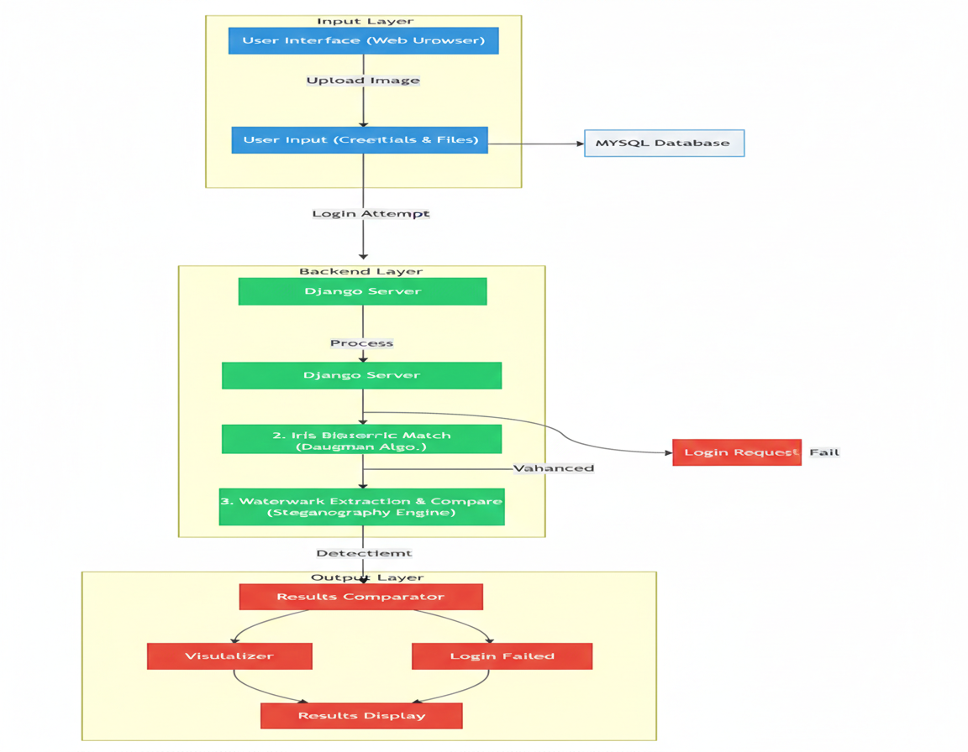

Fig.7.1.1 System architecture design

7.2. Use Case Diagram
The Use Case Diagram of a Graphical Password Authentication System using Iris Image and Watermarking. It illustrates how the user interacts with the system during registration and login processes, and how the system verifies the authenticity of the iris image using watermark techniques.

1. User (Actor)
The User is the primary actor in the system. The user interacts with the graphical password authentication system to either register a new account or log in to an existing account. The user provides credentials and an iris image that will be used for authentication.

2. Registration Process
The registration phase allows a new user to create an account in the system. This process includes the following steps:
Register
The user first selects the Register option to create a new account. During registration, the user provides necessary details such as:
- Username
- Password
- Iris image
This information will be used later during authentication.
Upload Iris Image
After entering the credentials, the user uploads an iris image. The iris image serves as a biometric graphical password. Since the iris pattern is unique for every person, it provides a highly secure authentication mechanism.
Embed Watermark
Once the iris image is uploaded, the system performs watermark embedding. In this process, a hidden digital watermark is inserted into the iris image using steganography techniques.
The watermark may contain:
- User identification data
- Authentication codes
- Security signatures
Embedding the watermark improves system security by protecting the image from tampering or duplication.

Store in Database
After watermark embedding, the processed iris image and user credentials are stored in the database. The database keeps:
- User credentials
- Watermarked iris image
- Authentication information
This stored data will later be used during the login verification process.

3. Login Process
The login process is used when an existing user wants to access the system.
Login
The user selects the Login option and enters their credentials along with the iris image.
Verify Username and Password
The system first verifies the username and password with the records stored in the database. If the credentials do not match, access is denied immediately.
If the credentials are correct, the system proceeds to biometric verification.
Verify Iris Image
In this step, the uploaded iris image is analyzed and compared with the iris template stored in the database. The system checks whether the iris pattern matches the registered user.
This biometric verification ensures that only the legitimate user can access the system.

4. Watermark Verification Process
Extract Watermark
After the iris image is verified, the system extracts the hidden watermark embedded during the registration process. This is done using watermark extraction techniques.
The extraction process retrieves the hidden data stored inside the iris image.
Validate Watermark
The extracted watermark is then compared with the original watermark stored in the database.
This step ensures:
- The image has not been modified
- The iris image belongs to the registered user
- The image integrity is maintained
If the watermark is valid, the authentication process continues.

5. Authentication Result
Authentication Success
If all verification steps are successful:
- Username and password match
- Iris image matches
- Watermark validation is correct
Then the system grants successful authentication and allows the user to access the application.
Authentication Failure
If any of the verification steps fail, such as:
- Incorrect credentials
- Iris mismatch
- Invalid watermark
The system returns authentication failure and denies access.
6. Role of the Database
The database plays an important role in storing and retrieving information required for authentication. It stores:
- User credentials
- Watermarked iris images
- Embedded watermark information
During login, the system retrieves these records to verify the user’s identity.
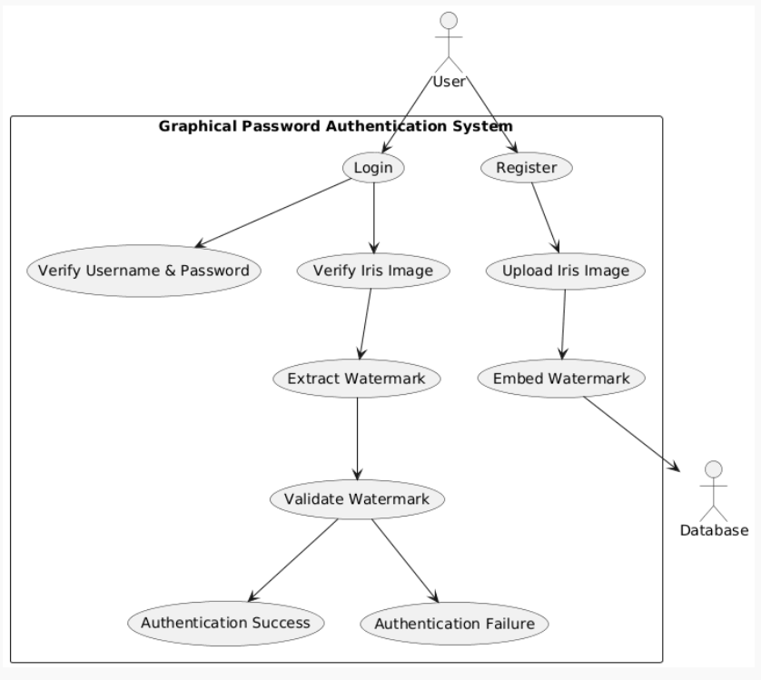
.

Fig 7.2.1: Use Case Diagram
7.3 Class Diagram:
A class diagram describes the structure of the system, its classes, attributes, methods, and relationships. This system integrates user authentication, iris biometric processing, watermark verification, and database management.

1. User Class
The User class represents the person who interacts with the authentication system. It contains the necessary information required for registration and login.
Attributes
- username – The unique identifier used to identify the user in the system.
- password – A secret credential used for primary authentication.
- Iris Image – The iris biometric image uploaded by the user.
- Watermark Message – A hidden message embedded inside the iris image for security purposes.
The user provides these details during registration and login processes.
Role
The user class sends the authentication request to the AuthenticationController for further processing.

2. AuthenticationController Class
The Authentication Controller acts as the main control unit of the system. It manages the overall authentication workflow by coordinating with other system components.
Methods
register()
Handles the user registration process. It receives user details and stores them in the database after processing.
login()
Handles user login requests by verifying credentials and biometric information.
validateCredentials()
Checks whether the provided username and password match the stored records in the database.
Role
The controller communicates with:
- IrisProcessor
- WatermarkProcessor
- Database
to complete the authentication process.

3. IrisProcessor Class
The IrisProcessor class is responsible for handling iris biometric recognition. It processes the iris image and extracts unique features for comparison.
Methods
extractIris()
Extracts the iris region from the uploaded eye image and prepares it for feature extraction.
compareIris()
Compares the extracted iris features with the stored iris template to determine whether the images match.
Role
The IrisProcessor uses the DaugmanAlgorithm class to generate iris codes and perform iris normalization
.
4. DaugmanAlgorithm Class
The DaugmanAlgorithm class implements the iris recognition algorithm developed by John Daugman. This algorithm is widely used in biometric systems.
Methods
normalizeIris()
Transforms the iris region into a normalized form to eliminate variations caused by lighting, pupil dilation, or image size.
generateIrisCode()
Converts the normalized iris pattern into a binary iris code that represents unique iris features.
Role
This iris code is used by the IrisProcessor for accurate biometric comparison.

5. WatermarkProcessor Class
The WatermarkProcessor class manages watermark embedding and verification operations. Watermarking is used to enhance security and protect the integrity of iris images.
Methods
embedWatermark()
Embeds a secret watermark message into the iris image during the registration phase.
extractWatermark()
Extracts the embedded watermark from the iris image during the login process.
compareWatermark()
Compares the extracted watermark with the stored watermark to verify the authenticity of the iris image.
Role
Watermark verification ensures that the iris image has not been tampered with or manipulated.

6. Database Class
The Database class represents the storage system used to manage user data.
Methods
storeUser()
Stores user details such as username, password, iris template, and watermark information during registration.
fetchUser()
Retrieves stored user data when the user attempts to log in.
Role
The database ensures secure storage and retrieval of au thentication data.
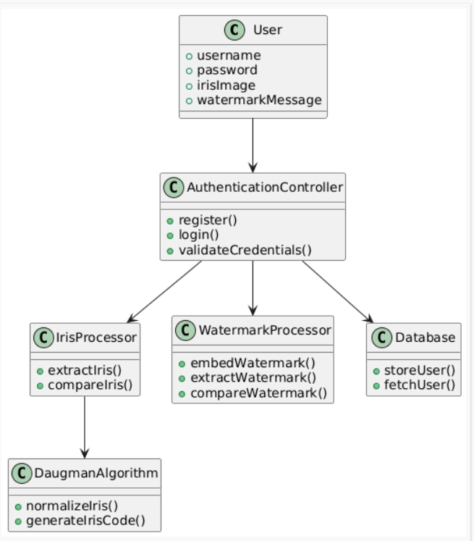

Fig.7.3.1: Class Diagram

7.4 Sequence Diagram
Sequence diagram shows how different components of the system interact with each other over time during the authentication process.

1. User Interaction
The process begins with the User, who initiates the authentication procedure. The user provides the required information through the system interface.
Input Provided by the User
The user enters:
- Username
- Password
- Iris image
- Watermark information
These inputs are submitted through the web application interface.

2. Web Application
The Web Application (Web App) acts as the front-end interface between the user and the backend system.
Login Request
After receiving the user inputs, the web application sends a login() request to the Authentication Controller.
The web application mainly performs the following tasks:
- Collects user credentials
- Sends authentication requests to the backend
- Displays authentication results to the user

3. Authentication Controller
The Authentication Controller is responsible for managing the authentication workflow. It coordinates with different system modules to verify the user's identity.
Username and Password Validation
First, the controller sends a request to the Database to validate the username and password.
Process:
- The controller sends a validate username and password request to the database.
- The database checks whether the provided credentials match the stored records.
- If the credentials are correct, the database returns a valid response.
4. Iris Image Verification
After the credentials are validated, the system proceeds to biometric verification.
Iris Processor
The Authentication Controller sends the iris image to the Iris Processor.
The iris processor performs the following steps:
- Feature extraction from the iris image
- Comparison of iris patterns with the stored template
Compare Iris Images
The iris processor compares:
- The uploaded iris image
- The stored iris template
If both iris patterns match, the processor sends a match response back to the authentication controller.
This step ensures that the person logging in is the actual registered user.

5. Watermark Extraction
Once the iris image is successfully verified, the system proceeds to the watermark verification stage.
Watermark Processor
The authentication controller sends the iris image to the Watermark Processor.
The watermark processor performs the following operations:
- Extract watermark
The hidden watermark embedded in the iris image during registration is extracted.
- Return watermark text
The extracted watermark information is sent back to the authentication controller.

6. Watermark Comparison
The authentication controller then compares the extracted watermark with the watermark stored in the database.
Compare Watermark
If the watermark matches the stored value, it confirms that:
- The iris image has not been modified
- The image belongs to the registered user
This step protects the system from tampered or forged biometric images.

7. Authentication Result
After completing all verification steps, the authentication controller determines the final result.
Authentication Success
If all conditions are satisfied:
- Username and password are correct
- Iris images match
- Watermark verification is valid
The system generates an Authentication Success response.
The response is sent from the Authentication Controller to the Web Application.

8. Welcome Message
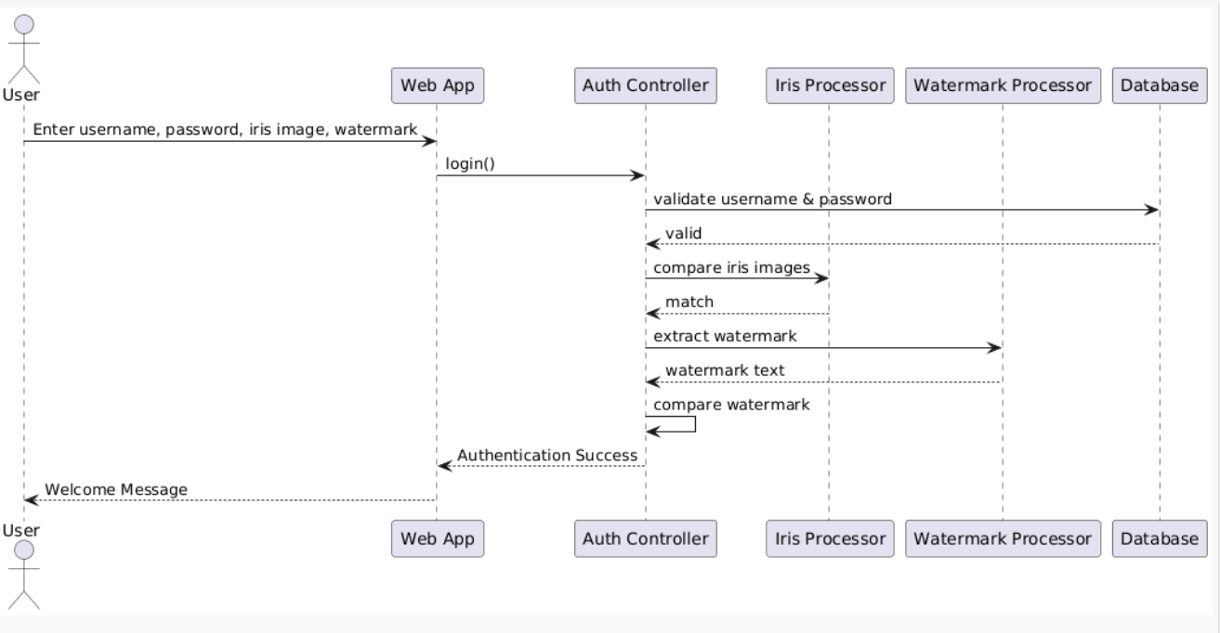
The web application then displays a Welcome Message to the user, indicating successful login and granting access to the system.
Fig.7.4.1: Sequence Diagram

7.5 Activity Diagram
An activity diagram illustrates the workflow of activities and decision points in the authentication process. It shows how the system processes user inputs and determines whether access should be granted or denied.
1. Start of the Process
The process begins at the initial node (black circle) which indicates the starting point of the authentication workflow.
At this stage, the system waits for the user to begin the login procedure.
2. Enter Login Details
The first activity in the process is “Enter login details.”
The user enters the following credentials:
- Username
- Password
These credentials are required to verify the user's identity in the system.
3. Upload Iris Image
After entering the login credentials, the user uploads an iris image. This iris image is used for biometric authentication.
Iris recognition is a reliable biometric technique because the iris pattern is unique for every individual.
The uploaded image will later be processed and compared with the iris template stored in the database.
4. Enter Watermark Message
In the next step, the user provides the watermark message associated with the iris image.
This watermark message is embedded in the iris image during the registration phase using watermarking or steganography techniques.
The watermark acts as an additional security layer to verify the authenticity and integrity of the image
5. Username and Password Validation
The system then checks whether the username and password are valid.
Decision Node: Username & Password Valid?
Two possible outcomes occur at this decision point:
Yes (Valid Credentials)
If the username and password are correct, the system proceeds to the next stage of authentication.
No (Invalid Credentials)
If the credentials are incorrect, the system displays Invalid Login and terminates the authentication process.

6. Iris Matching
If the credentials are valid, the system performs iris recognition.
Decision Node: Iris Match?
The system compares the uploaded iris image with the stored iris template.
Possible outcomes:
Yes (Iris Match)
If the iris patterns match, the system continues to the watermark verification stage.
No (Iris Mismatch)
If the iris patterns do not match, the system returns Iris Authentication Failed and terminates the authentication process.

7. Watermark Verification
If the iris authentication is successful, the system verifies the watermark embedded in the iris image.
Decision Node: Watermark Match?
The system extracts the watermark from the iris image and compares it with the watermark stored in the database.
Possible outcomes:
Yes (Watermark Match)
If the watermark is correct, the system confirms the image integrity and grants access.
No (Watermark Mismatch)
If the watermark does not match, the system displays Watermark Authentication Failed.

8. Grant Access
If all authentication steps are successful:
- Username and password are valid
- Iris image matches
- Watermark verification is correct
The system grants access to the user.
The user can now access the system resources.

9. Failure Conditions
The system may deny access in the following situations:
Invalid Login
Occurs when:
- Username or password is incorrect.
Iris Authentication Failed
Occurs when:
- The uploaded iris image does not match the stored iris template.
Watermark Authentication Failed
Occurs when:
- The extracted watermark does not match the stored watermark.
These failures prevent unauthorized users from accessing the system.

10. End of the Process
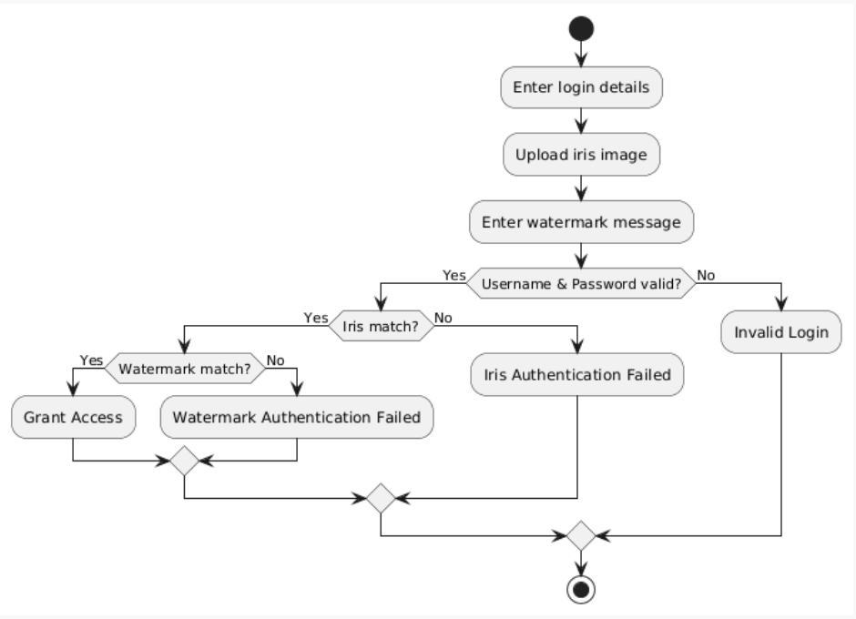
After either granting access or denying authentication, the process reaches the final node (end state) indicating the completion of the authentication workflow

Fig.7.5.1: Activity Diagram

8.ALGORITHMS

The proposed system integrates cryptography, digital image processing, image recognition, and watermarking to provide a secure multi-factor authentication mechanism. Each algorithm contributes to a specific stage of the system.

1. Password Hashing Algorithm (SHA-256 / bcrypt)
Theory
Password hashing ensures that user passwords are not stored in plain text. A one-way hash function converts the password into a fixed-length output that cannot be reversed.
Mathematical Representation
$$H=SHA256(P ∣∣ S)$$
Where:
- $P$= Password
- $S$= Salt (random value added for security)
- $∣∣$= Concatenation
- $H$= Hash output
Working Steps
- User enters password $P$
- Generate random salt $S$
- Combine password and salt: $P∣∣S$
- Apply SHA-256 hashing
- Store $H$and $S$in database
- During login, repeat the same process and compare hashes
Security Advantage
- Prevents password leakage
- Resistant to rainbow table attacks

2. Digital Watermarking Algorithm (LSB / DWT / DCT)
Theory
Watermarking hides secret data inside an image without affecting its visual quality.
(A) LSB Method (Simple Implementation)

(A) LSB Method (Simple Implementation)
Mathematical Formula
$$I^{'}(x,y)=(I(x,y)\&254) ∣ W(x,y)$$
Where:
- $I(x,y)$= Original pixel
- $W(x,y)∈\{0,1\}$= Watermark bit
- $I^{'}(x,y)$= Modified pixel
Steps
- Convert watermark message into binary
- Select pixel values from iris image
- Replace LSB with watermark bits
- Generate watermarked image

(B) DWT Method (Advanced)
Mathematical Concept
Apply wavelet transform:
$$I(x,y)→LL,LH,HL,HH$$
Embed watermark in frequency bands:
$$LL^{'}=LL+αW$$
Where $α$= scaling factor
Advantage
- More robust against attacks
- Better image quality preservation

3. Watermark Extraction Algorithm
Theory
Extract hidden information from the watermarked image.
Formula (LSB)
$$W(x,y)=I^{'}(x,y)\&1$$

Steps
- Input watermarked image
- Extract LSB bits
- Reconstruct binary sequence
- Convert to original message
- Compare with stored watermark

4. Iris Matching Algorithm (Hamming Distance)
Theory
Measures similarity between two iris codes.
Formula
$$HD=\frac{1}{N}\sum_{i=1}^{N}{(}X_{i}⊕Y_{i})$$
Steps
- Input stored iris code $X$
- Input login iris code $Y$
- Perform XOR operation
- Count mismatches
- Calculate HD
- If $HD<0.3$→ Match

5. Image Preprocessing Algorithm
Theory
Enhances image quality before processing.

(A) Gaussian Filter
$$G(x,y)=\frac{1}{2πσ^{2}}e^{-\frac{x^{2}+y^{2}}{2σ^{2}}}$$
(B) Histogram Equalization
$$s_{k}=(L-1)\sum_{j=0}^{k}{p(}r_{j})$$

Steps
- Input raw iris image
- Apply Gaussian filter (noise removal)
- Apply histogram equalization
- Normalize brightness

6. Multi-Factor Authentication Algorithm
Theory
Final decision-making algorithm combining all factors.
Mathematical Expression
$$Auth=(H_{input}=H_{stored})∧(W_{input}=W_{stored})∧(HD<T)$$
Steps
- Input username, password, iris image
- Verify password hash
- Extract watermark
- Compare watermark
- Perform iris matching
- If all conditions true → Access Granted
- Else → Access Denied

9.IMPLEMENTATION
9.1 Sample Code:

import cv2
import numpy as np
import itertools
import math
from typing import Tuple, List

def daugman(gray_img: np.ndarray, center: Tuple[int, int],
start_r: int, end_r: int, step: int = 1) -> Tuple[float, int]:
""" The function will calculate pixel intensities for the circles
in the ``range(start_r, end_r, step)`` for a given ``center``,
and find a circle that precedes the biggest intensity drop
:param gray_img: grayscale picture
:param center: center coordinates ``(x, y)``
:param start_r: bottom value for iris radius in pixels
:param end_r: top value for iris radius in pixels
:param step: step value for iris radii range in pixels
.. attention::
Input grayscale image should be a square, not a rectangle
:return: intensity_value, radius
"""
x, y = center
intensities = []
mask = np.zeros_like(gray_img)

# for every radius in range
radii = list(range(start_r, end_r, step)) # type: List[int]
for r in radii:
# draw circle on mask
cv2.circle(mask, center, r, 255, 1)
# get pixel from original image, it is faster than np or cv2
diff = gray_img & mask
# normalize, np.add.reduce faster than .sum()
# diff[diff > 0] faster than .flatten()
intensities.append(np.add.reduce(diff[diff > 0]) / (2 * math.pi * r))
# refresh mask
mask.fill(0)

# calculate delta of radius intensitiveness
# mypy does not tolerate var type reload
intensities_np = np.array(intensities, dtype=np.float32)
del intensities

# circles intensity differences, x5 faster than np.diff()
intensities_np = intensities_np[:-1] - intensities_np[1:]
# aply gaussian filter
# GaussianBlur() faster than filter2D() with custom kernel
# original kernel:
# > The Gaussian filter in our case is designedin MATLAB and
# > is a 1 by 5 (rows by columns) vector with intensity values
# > given by vector A = [0.0003 0.1065 0.7866 0.1065 0.0003]
intensities_np = abs(cv2.GaussianBlur(intensities_np, (1, 5), 0))
# get maximum value
idx = np.argmax(intensities_np) # type: int

# return intensity value, radius
return intensities_np[idx], radii[idx]

def find_iris(gray: np.ndarray, *,
daugman_start: int, daugman_end: int,
daugman_step: int = 1, points_step: int = 1,) -> Tuple[Tuple[int, int], int]:
""" The function will apply :func:`daugman` on every pixel in the calculated image slice.
Basically, we are calculating where lies set of valid circle centers.
It is assumed that iris center lies within central 1/3 of the image.
:param gray: graysacale **square** image
:param points_step: it will run daugman for each ``points_step``th point.
It has linear correlation with overall iris search speed
:param daugman_start: bottom value for iris radius in pixels for :func:``daugman``
:param daugman_end: top value for iris radius in pixels for :func:``daugman``
:param daugman_step: step value for iris radii range in pixels for :func:``daugman``.
It has linear correlation with overall iris search speed
:return: radius with biggest intensiveness delta on image as ``((xc, yc), radius)``
"""
h, w = gray.shape
if h != w:
print('Your image is not a square!')

# reduce step for better accuracy
# we will look only on dots within central 1/3 of image
single_axis_range = range(int(h / 3), h - int(h / 3), points_step)
all_points = itertools.product(single_axis_range, single_axis_range)

intensity_values = []
coords = [] # List[Tuple[Tuple(int, int), int]]

for point in all_points:
val, r = daugman(gray, point, daugman_start, daugman_end, daugman_step)
intensity_values.append(val)
coords.append((point, r))

# return the radius with biggest intensiveness delta on image
# ((xc, yc), radius)
# x10 faster than coords[np.argmax(values)]
best_idx = intensity_values.index(max(intensity_values))
return coords[best_idx]

#!/usr/bin/env python
import os
import sys

if __name__ == '__main__':
os.environ.setdefault('DJANGO_SETTINGS_MODULE', 'IrisAuth.settings')
try:
from django.core.management import execute_from_command_line
except ImportError as exc:
raise ImportError(
"Couldn't import Django. Are you sure it's installed and "
"available on your PYTHONPATH environment variable? Did you "
"forget to activate a virtual environment?"
) from exc
execute_from_command_line(sys.argv)

from cryptosteganography import CryptoSteganography
from Daugman import find_iris
import cv2

def watermarkImage(image):
img = cv2.imread(image)
img = cv2.resize(img,(128,128), interpolation=cv2.INTER_CUBIC)
gray_img = cv2.cvtColor(img, cv2.COLOR_BGR2GRAY)
answer = find_iris(gray_img, daugman_start=10, daugman_end=30, daugman_step=1, points_step=3)
iris_center, iris_rad = answer
start = iris_center[0]
end = iris_center[1]
radius = iris_rad
result = img[start-radius:start+radius,end-radius:end+radius]
result = cv2.resize(result, (64,64), interpolation=cv2.INTER_CUBIC)
segmented = result
print(str(start)+" "+str(end))
cv2.imwrite("segment.png", segmented)

watermarkImage('IrisAuthApp/static/images/tra.jpg')

crypto_steganography = CryptoSteganography('securehiding')
message = 'welcome to java world hello'
crypto_steganography.hide("segment.png", 'output_stego_image.png', message)

crypto_steganography = CryptoSteganography('securehiding')
secret = crypto_steganography.retrieve('output_stego_image.png')
print("welcome "+secret)

import pymysql
print(pymysql.__file__)
pymysql.install_as_MySQLdb()

9.3 Sample Dataset
Test Images
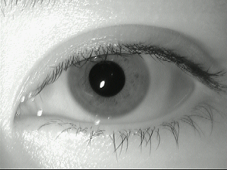
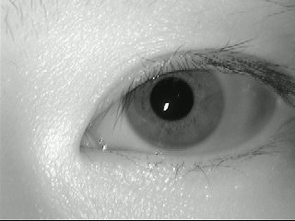
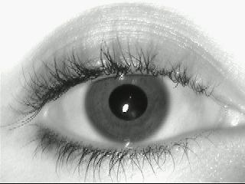

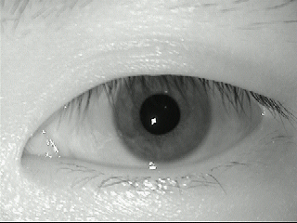
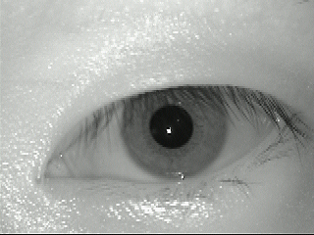
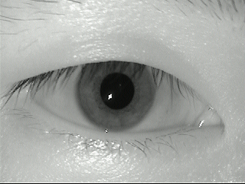
10.TESTING

Testing of the Proposed System
Testing is an important phase in the development of any software system. It ensures that the system functions correctly and meets the specified requirements. In the proposed Graphical Password Authentication System, testing is performed to verify that all modules such as user registration, iris recognition, watermark embedding, and authentication operate accurately and securely. The objective of testing is to identify errors, validate system performance, and ensure that the application provides reliable authentication.
The system undergoes different levels of testing to ensure that each component works individually as well as when integrated with other modules.

1. Unit Testing
Unit testing is performed to test each module of the system independently. In this phase, individual components such as the user registration module, watermark embedding module, iris processing module, and authentication module are tested separately to verify their correctness.
For example:
- The registration module is tested to ensure that user credentials are correctly accepted and stored.
- The watermark embedding module is tested to verify that the secret message is properly embedded into the iris image.
- The iris processing module is tested to ensure accurate feature extraction from the iris image.
Unit testing helps detect errors at the early stages of development and ensures that each module performs its intended function.

2. Integration Testing
Integration testing verifies the interaction between different modules of the system. After unit testing is completed, the modules are combined and tested together to ensure smooth data flow and communication.
For example:
- The registration module is integrated with the watermark embedding module and database module.
- The login module is integrated with watermark extraction and iris matching modules.
Integration testing ensures that the combined modules work together correctly without data inconsistencies or communication errors.

3. System Testing
System testing is performed on the complete system to ensure that it meets all functional and non-functional requirements. In this phase, the entire authentication workflow is tested from user registration to successful login.
The system is tested to verify that:
- Users can successfully register and store their authentication credentials.
- The watermark is correctly embedded and retrieved from the iris image.
- Iris recognition accurately identifies the registered user.
- The system grants access only when all authentication parameters match.
System testing confirms that the system functions as expected in real operating conditions.

4. Security Testing
Security testing is conducted to ensure that the authentication system is resistant to various attacks and unauthorized access attempts. Since the system uses biometric authentication and digital watermarking, it is essential to verify that the security mechanisms are effective.
Security testing includes:
- Testing the system against password guessing attacks.
- Verifying that the watermark cannot be easily removed or altered.
- Ensuring that biometric templates are securely stored in the database.
- Checking that unauthorized users cannot bypass authentication.
This testing ensures that the system provides a high level of protection for user data.

5. Performance Testing
Performance testing evaluates the system's efficiency and response time under different conditions. The system is tested to ensure that authentication processes such as watermark extraction and iris matching are completed within an acceptable time.
The performance testing verifies that:
- The system processes login requests quickly.
- The database handles multiple user records efficiently.
- The system performs reliably even with a large number of users.

6. User Acceptance Testing
User Acceptance Testing (UAT) is conducted to ensure that the system meets the expectations of end users. In this phase, the application is tested from the user’s perspective to verify ease of use and functionality.
Users evaluate:
- Simplicity of registration and login process
- Ease of uploading iris images
- Clarity of system messages and responses
- Overall usability of the interface
Feedback obtained during this stage helps improve the system before deployment.

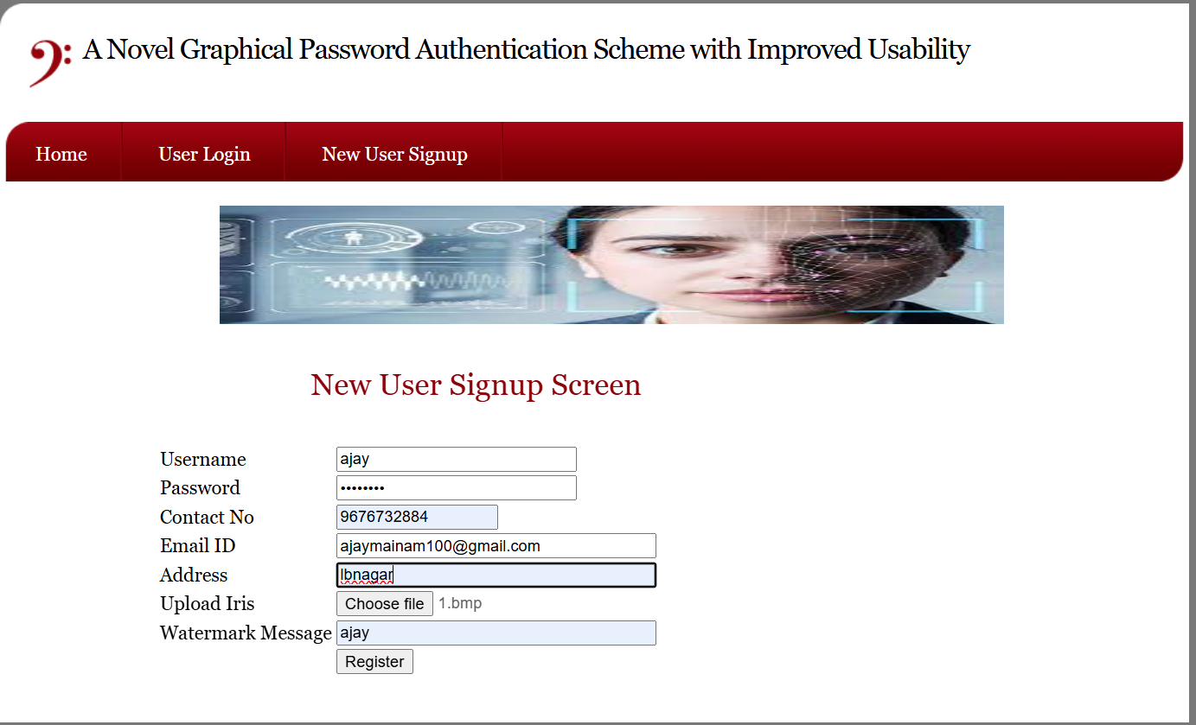
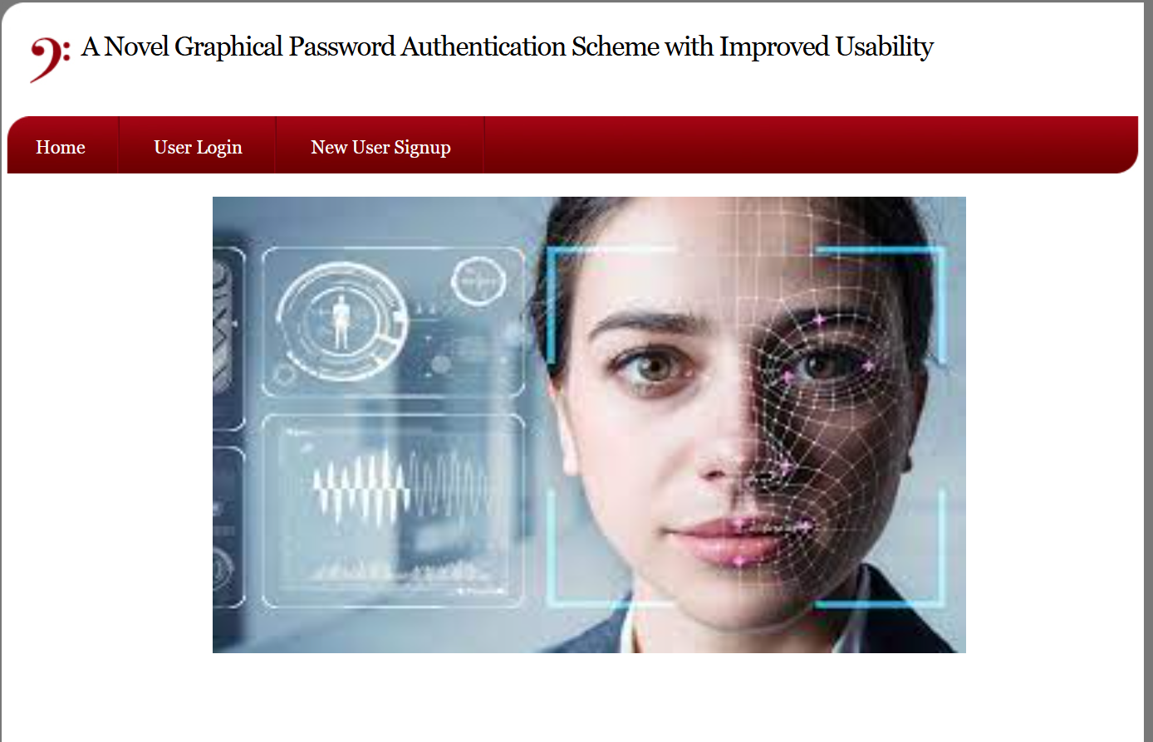
11.OUTPUT SCREENSHOTS

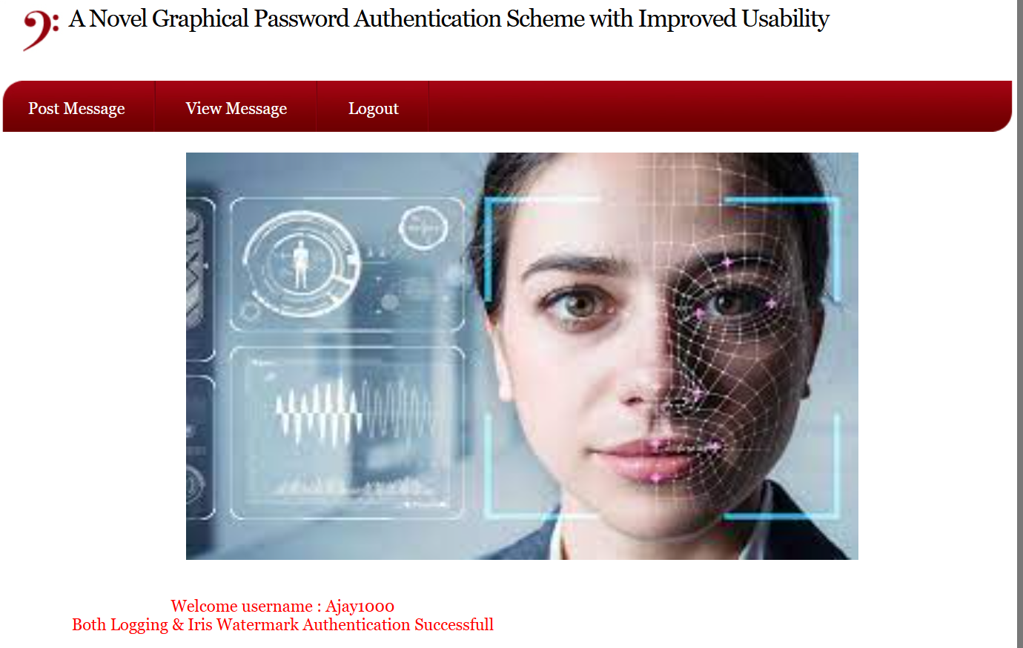
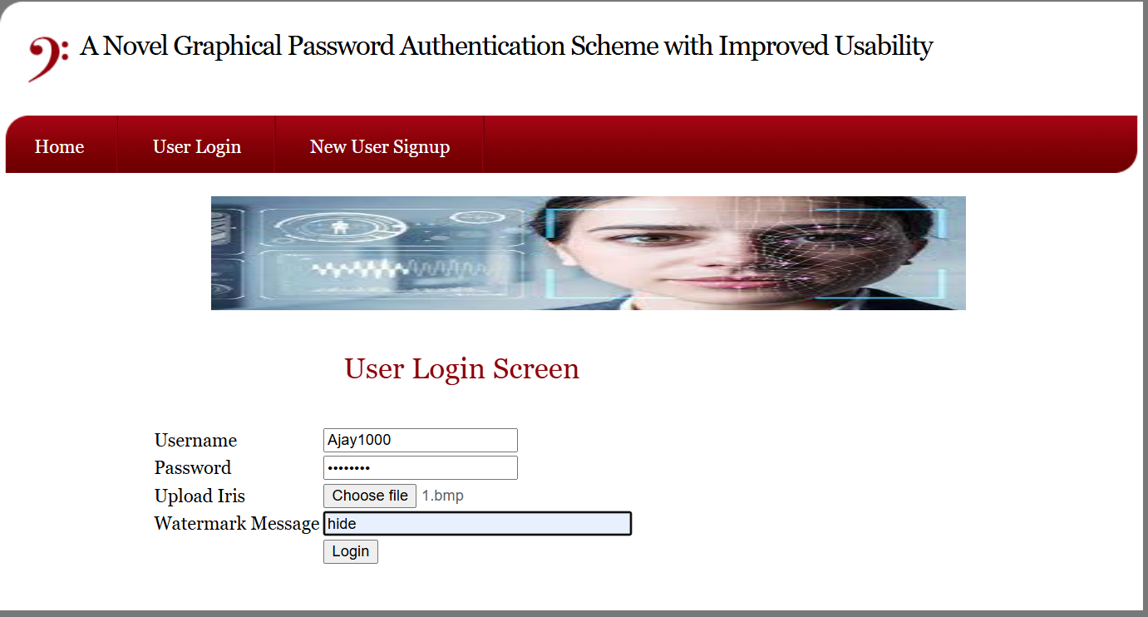

- CONCLUSION

The project titles “Graphical Password Authentication” System provides a secure and efficient approach to user authentication by integrating traditional password mechanisms with iris biometric recognition and digital watermarking techniques. Conventional authentication systems that rely solely on text-based passwords are highly vulnerable to various security threats such as brute-force attacks, password guessing, phishing, and unauthorized access. To overcome these limitations, the proposed system introduces a multi-layered authentication process that significantly enhances security and reliability.

In this system, the user is required to provide a username, password, iris image, and a secret watermark message during registration. The watermark message is embedded into the iris image using digital watermarking techniques and stored securely in the database. During the login process, the system verifies the user's credentials by checking the password, extracting the watermark from the uploaded iris image, and matching the biometric features of the iris. Authentication is granted only when all these parameters match successfully.

The integration of biometric authentication and digital watermarking improves the robustness of the system and reduces the chances of identity theft or unauthorized access. The use of iris recognition ensures high accuracy because the iris pattern is unique for every individual and remains stable over time. Similarly, watermarking protects the integrity of the biometric image and prevents tampering or duplication.

The system also emphasizes usability and efficiency, ensuring that the authentication process remains user-friendly while maintaining high security standards. Through proper testing and validation, the proposed model demonstrates reliable performance and secure authentication in practical scenarios.
In conclusion, the proposed graphical password authentication system offers an effective solution for modern security challenges by combining knowledge-based, biometric, and graphical authentication techniques. This multi-factor authentication approach enhances system security, protects sensitive data, and provides a dependable authentication mechanism for applications requiring high levels of protection such as banking systems, secure networks, and enterprise platforms.

13.FUTURE SCOPE

The proposed Graphical Password Authentication System using Iris Recognition and Digital Watermarking provides a secure multi-factor authentication mechanism. Although the system offers enhanced security and reliability, there is still significant scope for further improvements and advancements in the future. The following points describe possible future enhancements that can be implemented to improve the system’s efficiency, scalability, and security.

One potential improvement is the integration of additional biometric modalities such as fingerprint recognition, facial recognition, or voice authentication. By incorporating multiple biometric factors, the system can become a fully multimodal biometric authentication system, which would further increase accuracy and reduce the chances of spoofing attacks.

Another future enhancement is the implementation of advanced watermarking techniques. Instead of simple watermark embedding methods, more sophisticated algorithms such as deep learning–based watermarking or adaptive watermarking can be used. These techniques can improve the robustness of watermarking against image manipulation, compression, or noise.

The system can also be improved by incorporating liveness detection mechanisms in iris recognition. This feature would help the system distinguish between a real human iris and a fake image or photograph, thereby preventing spoofing attacks and improving biometric security.
In the future, the system may be integrated with cloud-based authentication services to support large-scale applications. Cloud integration would enable secure storage of biometric templates, faster processing, and easy access across multiple platforms and devices.

Another possible extension is the development of a mobile-based authentication application. By integrating the system with smartphones and mobile cameras, users could easily capture iris images and perform secure authentication through mobile devices, making the system more accessible and convenient.

14.REFERENCES

- Mohammed A. M. Abdullah, S. S. Dlay, and W. L. Woo, “Securing Iris Images with a Robust Watermarking Algorithm based on Discrete Cosine Transform,” SCITEPRESS (2015). (SciTePress)
  - PDF: https://www.scitepress.org/papers/2015/53057/53057.pdf (SciTePress)
- S. Joyce and S. Veni, “Iris Biometric Watermarking for Authentication Using Multiband Discrete Wavelet Transform and Singular-Value Decomposition,” International Journal of Electrical and Computer Engineering Systems, vol. 14, no. 3, pp. 259–266, Mar. 2023. (ijeces.ferit.hr)
  - DOI / Link: https://doi.org/10.32985/ijeces.14.3.3 (ijeces.ferit.hr)
- Rasha Thabit and Saad Shukr, “Iris Image Watermarking Technique for Security and Manipulation Reveal,” International Journal on Informatics Visualization, (year). (joiv.org)
  - DOI / Link: http://dx.doi.org/10.30630/joiv.6.4.1287 (joiv.org)
- Malay Kishore Dutta, Anushikha Singh, and Tanveer Zia, “An efficient and secure digital image watermarking using features from iris image,” Proceedings of the IEEE International Conference on Control, Communication and Computing (ICCC) – 2013. (researchoutput.csu.edu.au)
  - DOI / Link: https://doi.org/10.1109/ICCC.2013.6731697 (researchoutput.csu.edu.au)
- Mayank Vatsa, Richa Singh, P. Mitra, and A. Noore, “Digital Watermarking Based Secure Multimodal Biometric System,” IIT Jodhpur Research Publication. (research.iitj.ac.in)
  - DOI / Link: 10.1109/ICSMC.2004.1400787 (research.iitj.ac.in)
- Priyanka Singh, Kilari Jyothsna Devi, Hiren Kumar Thakkar, and José Santamaría, “Blind and Secured Adaptive Digital Image Watermarking Approach for High Imperceptibility and Robustness,” Entropy, vol. 23, no. 12, (2021). (MDPI)
  - DOI / Link: https://doi.org/10.3390/e23121650 (MDPI)
- S. Usha and M. Karthik, “A Robust Digital Image Watermarking for Biometric Template Protection Applications,” International Journal of Advanced Research in Electrical, Electronics and Instrumentation Engineering, Vol. 4, Issue 4 (2015).
- Basna Mohammed Salih Hasan, Siddeeq Y. Ameen, and Omer Mohammed Salih Hasan, “Image Authentication Based on Watermarking Approach: Review,” Asian Journal of Research in Computer Science, vol. 9, no. 3 (2021). (journalajrcos.com)
  - DOI / Link: 10.9734/ajrcos/2021/v9i330224 (journalajrcos.com)
- C. Christy, A. Baskaran, and P. Arunmani, “A Survey on Digital Watermarking for Image Authentication,” International Journal of Engineering Research & Technology (IJERT), NCETCS 2016. (IJERT)

